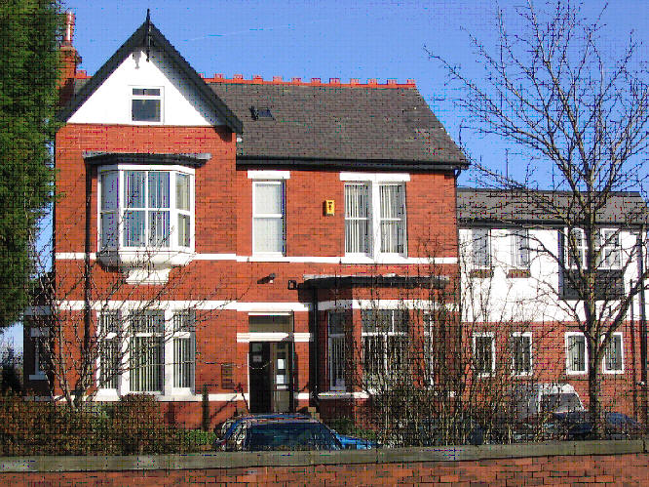
Telephone: 01704 226973
Dr. S.D. Tobin
Dr. A. Al-Dahiri
Dr. A. Zubairu
Dr. D. Byrne
Dr S.Fu

NORWOOD SURGERY
11 Norwood Avenue, Southport PR9 7EG
Your data, privacy and the Law. How we use your medical records

- This practice handles medical records according to the laws on data protection and confidentiality.

- We share medical records with health professionals who are involved in providing you with care and treatment. This is on a need to know basis and event by event.

- Some of your data is automatically copied to the Shared Care Summary Record

- We do share some of your data with local out of hours / urgent or emergency care service

- Data about you is used to manage national screening campaigns such as Flu, Cervical cytology and Diabetes prevention.

- Data is shared with the CCG (Medicines Management team)

- Data is shared with Coloplast who provide Stoma Products

- Data about you is de-identified and used to help the Primary Care Network (PCN)

- Data is shared with GP and Southport and Formby Health Ltd.

- Data about you is de-identified and used to generate chronic disease recall with Arden’s Healthcare Informatics

- Data about you, usually de-identified, is used to manage the NHS and make payments.

- We share information when the law requires us to do, for instance when we are inspected or reporting certain illnesses or safeguarding vulnerable people.

- Your data is used to check the quality of care provided by the NHS.

- We may also share medical records for medical research

- Your data is shared with noteSpace; part of the Oasis Group, who upload your consent forms for COVID vaccinations.

For more information please visit our website http://www.norwoodsurgerysouthport.nhs.uk/

